Lab 7 Summary

Irvin, Mitchell

Section 7441

3/18/16

PART 1

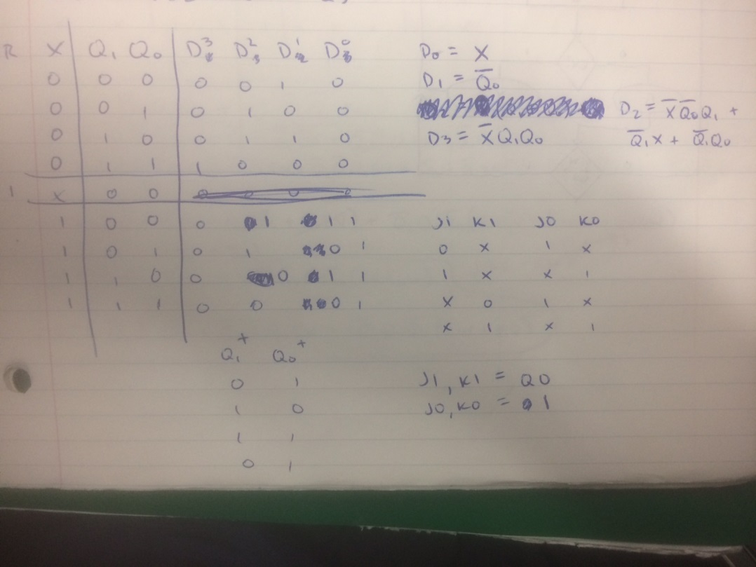

Next state table for part 1 (counter) w/ simplified equations

BDF for counter

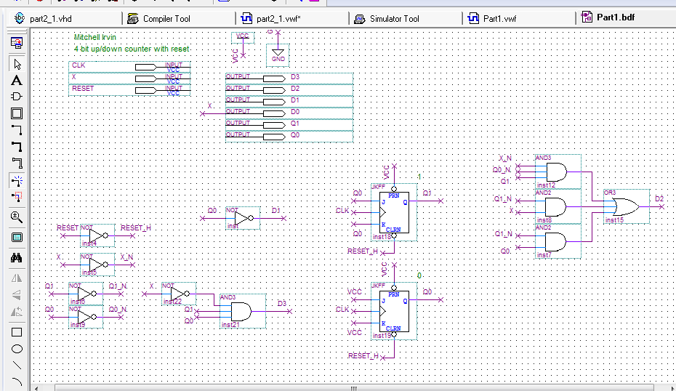

VWF simulation for counter

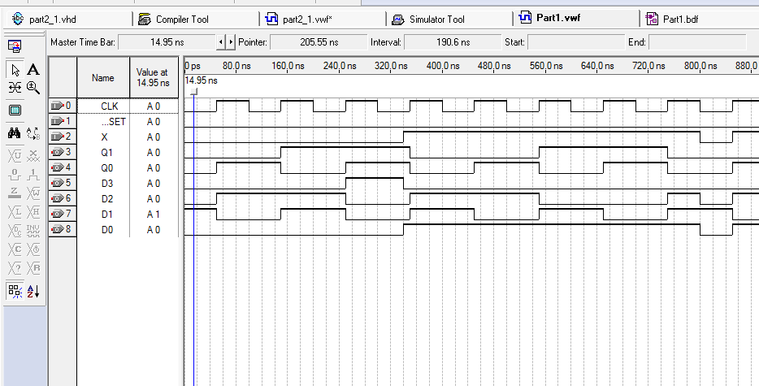

PART 2

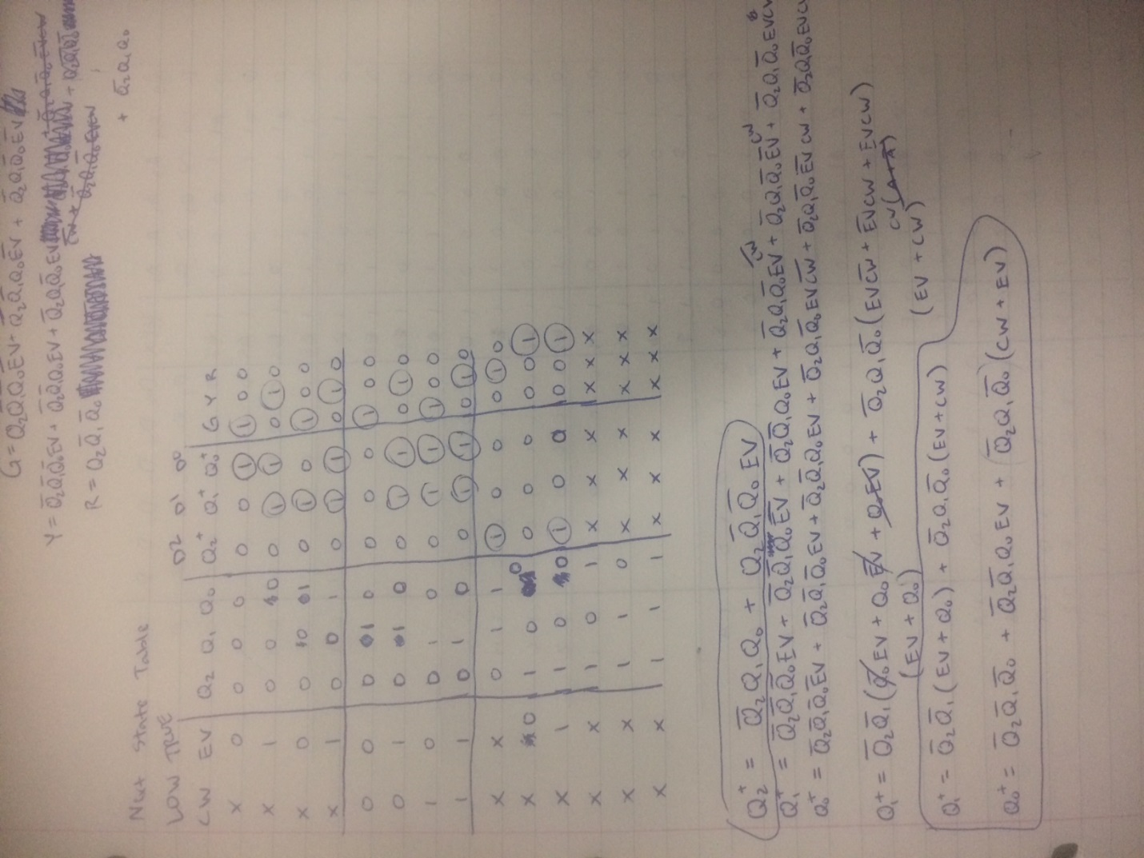

next state table and simplified equations

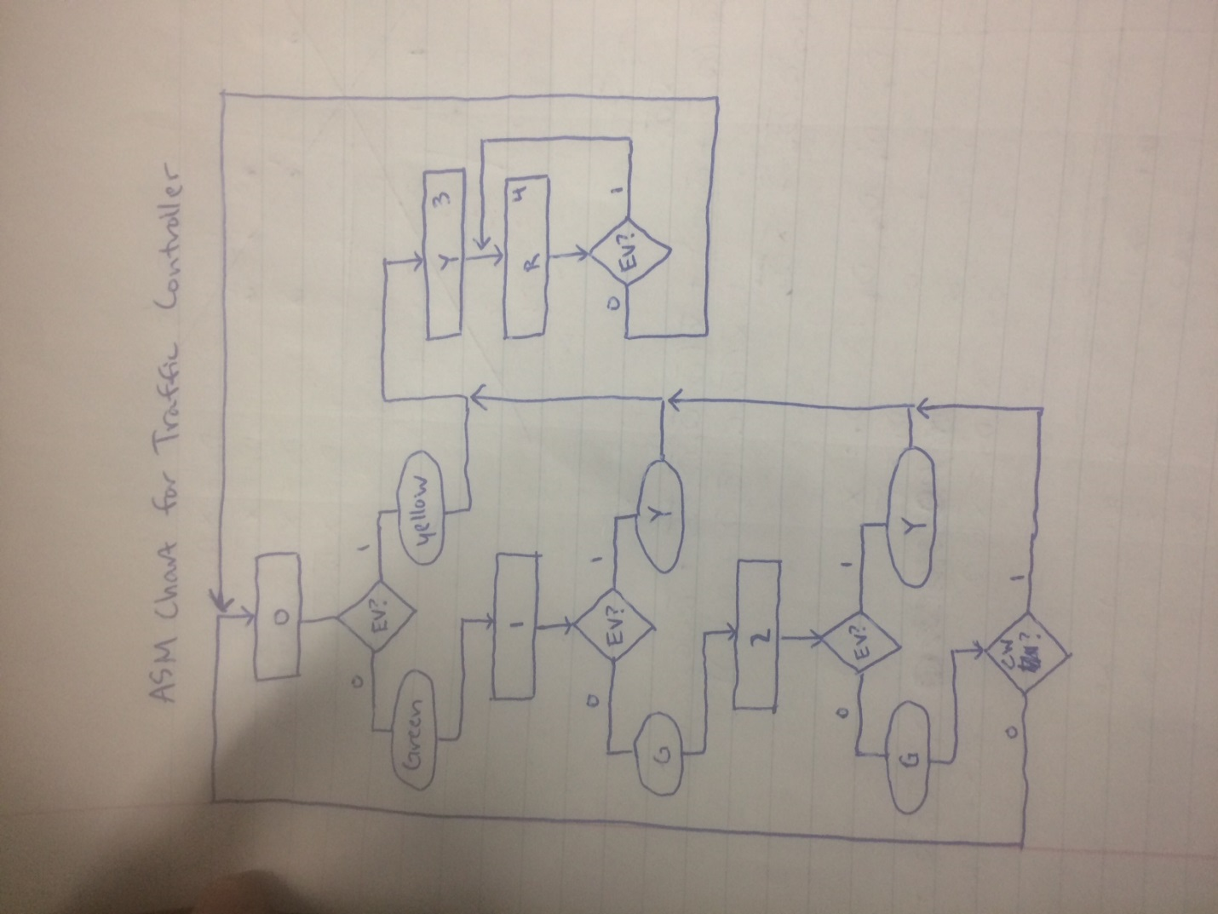

the ASM for the logic of part 2

VHD for part 2 logic

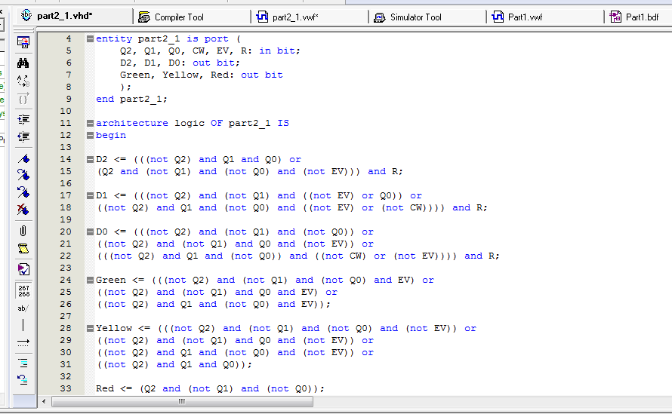

VWF for part 2 logic

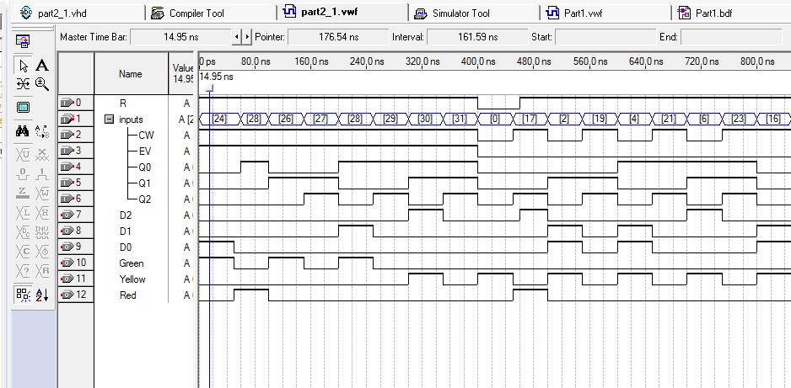

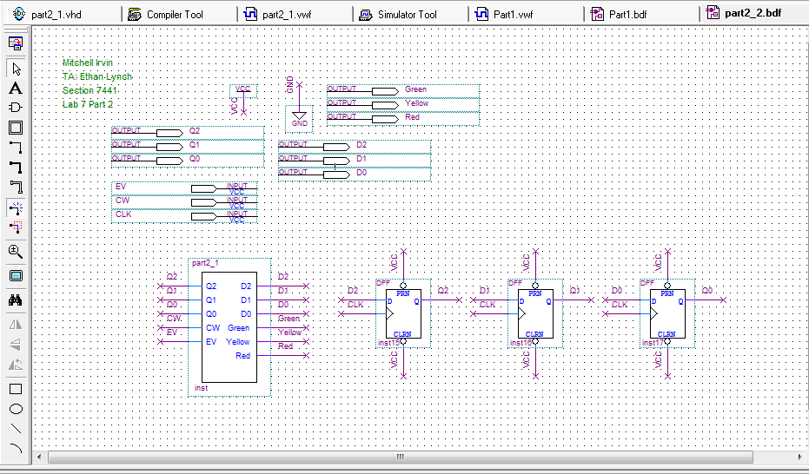

Part 2 implementation bdf

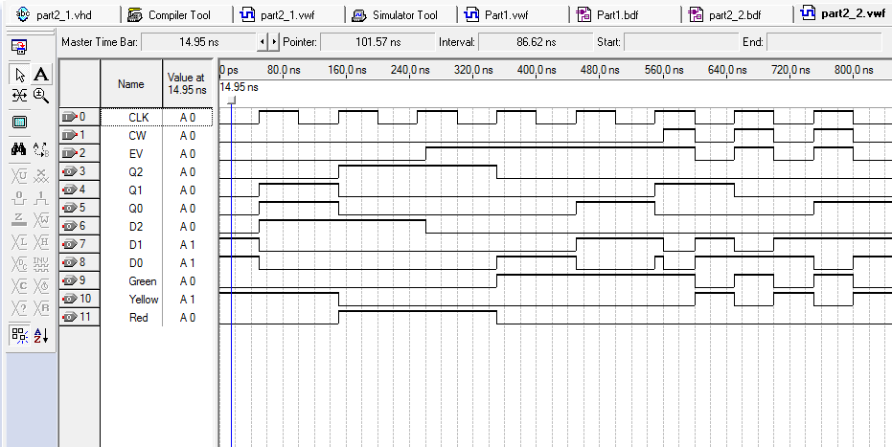

Part 2 implementation VWF

Memory table w/ addresses and Data bits

